Exercise 09

In this practice, you add rows to the MY_EMPLOYEE table, update and delete data from the table, and control your transactions. You run a script to create the MY_EMPLOYEE table.

The HR department wants you to create SQL statements to insert, update, and delete employee data. As a prototype, you use the MY_EMPLOYEE table before giving the statements to the HR department.

**Note:** For all the DML statements, use the Run Script icon (or press [F5]) to execute the query. This way you get to see the feedback messages on the Script Output tab page. For SELECT queries, continue to use the Execute Statement icon or press [F9] to get the formatted output on the Results tab page.

1. Run the statement in the lab_09_01.sql script to build the MY_EMPLOYEE table used in this practice.
2. Describe the structure of the MY_EMPLOYEE table to identify the column names.
3. Create an INSERT statement to add *the first row* of data to the MY_EMPLOYEE table from the following sample data. Do not list the columns in the INSERT clause. *Do not enter all rows yet*.
4. Populate the MY_EMPLOYEE table with the second row of the sample data from the preceding list. This time, list the columns explicitly in the INSERT clause.
5. Confirm your addition to the table.
6. Write an INSERT statement in a dynamic reusable script file to load the remaining rows into the MY_EMPLOYEE table. The script should prompt for all the columns (ID, LAST_NAME, FIRST_NAME, USERID, and SALARY). Save this script to a lab_09_06.sql file.
7. Populate the table with the next two rows of the sample data listed in step 3 by running the INSERT statement in the script that you created.
8. Confirm your additions to the table.
9. Make the data additions permanent.

Update and delete data in the MY_EMPLOYEE table.

1. Change the last name of employee 3 to Drexler.
2. Change the salary to $1,000 for all employees who have a salary less than $900.
3. Verify your changes to the table.
4. Delete Betty Dancs from the MY_EMPLOYEE table.
5. Confirm your changes to the table.
6. Commit all pending changes.

Control data transaction to the MY_EMPLOYEE table.

1. Populate the table with the last row of the sample data listed in step 3 by using the statements in the script that you created in step 6. Run the statements in the script.
2. Confirm your addition to the table.

1.

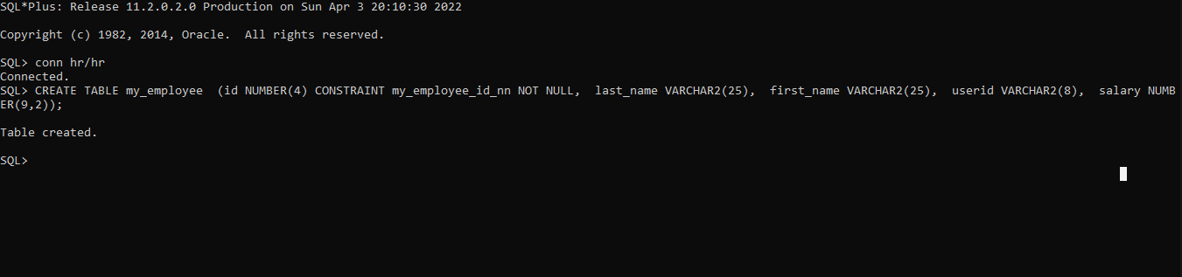

2.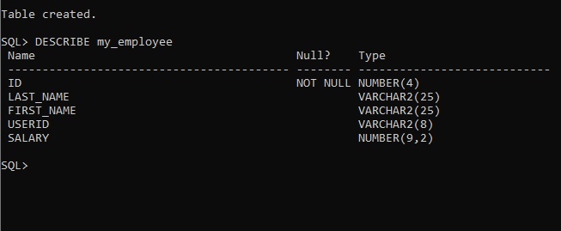

3.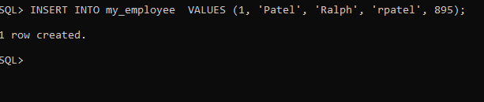

4.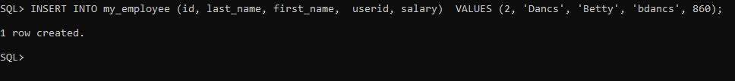

5.

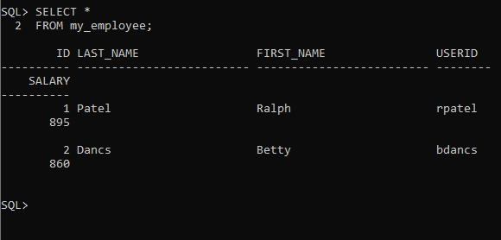

6.

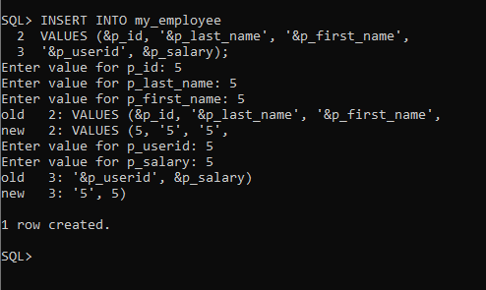

7.

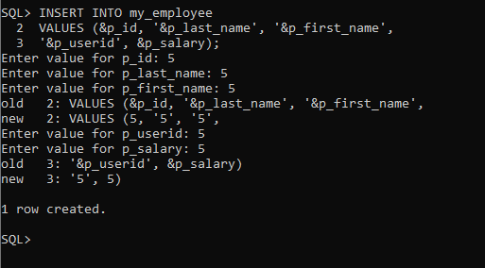

8.

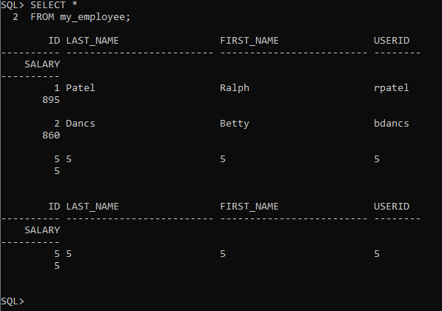

9.

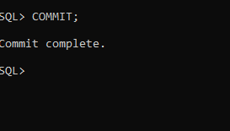

10.

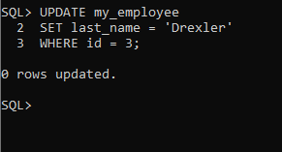

11.

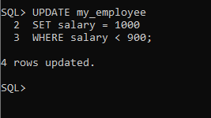

12.

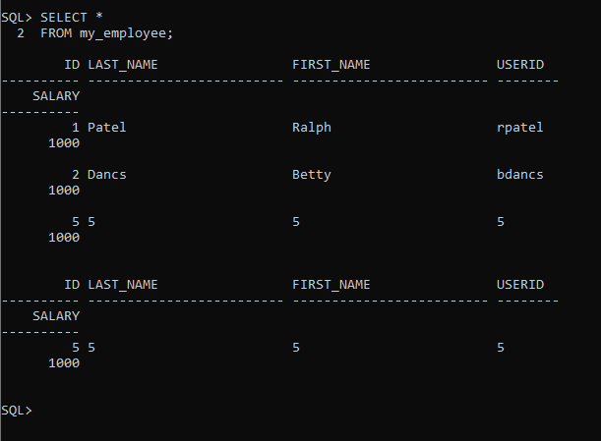

13.

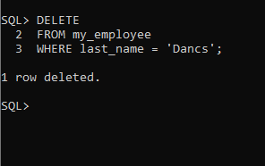

14.

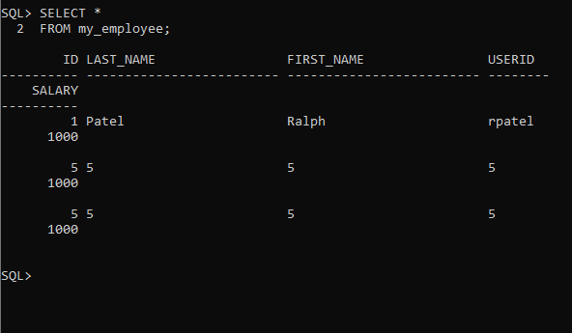

15.

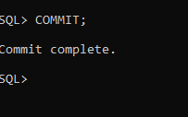

16.

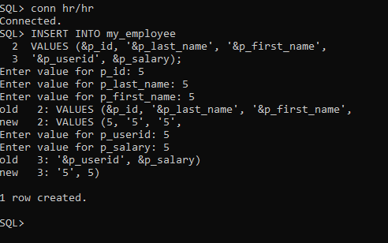

17.

